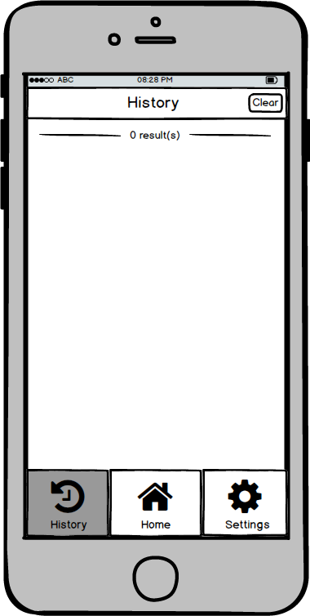

O 828 PM

History

**O result(s)**